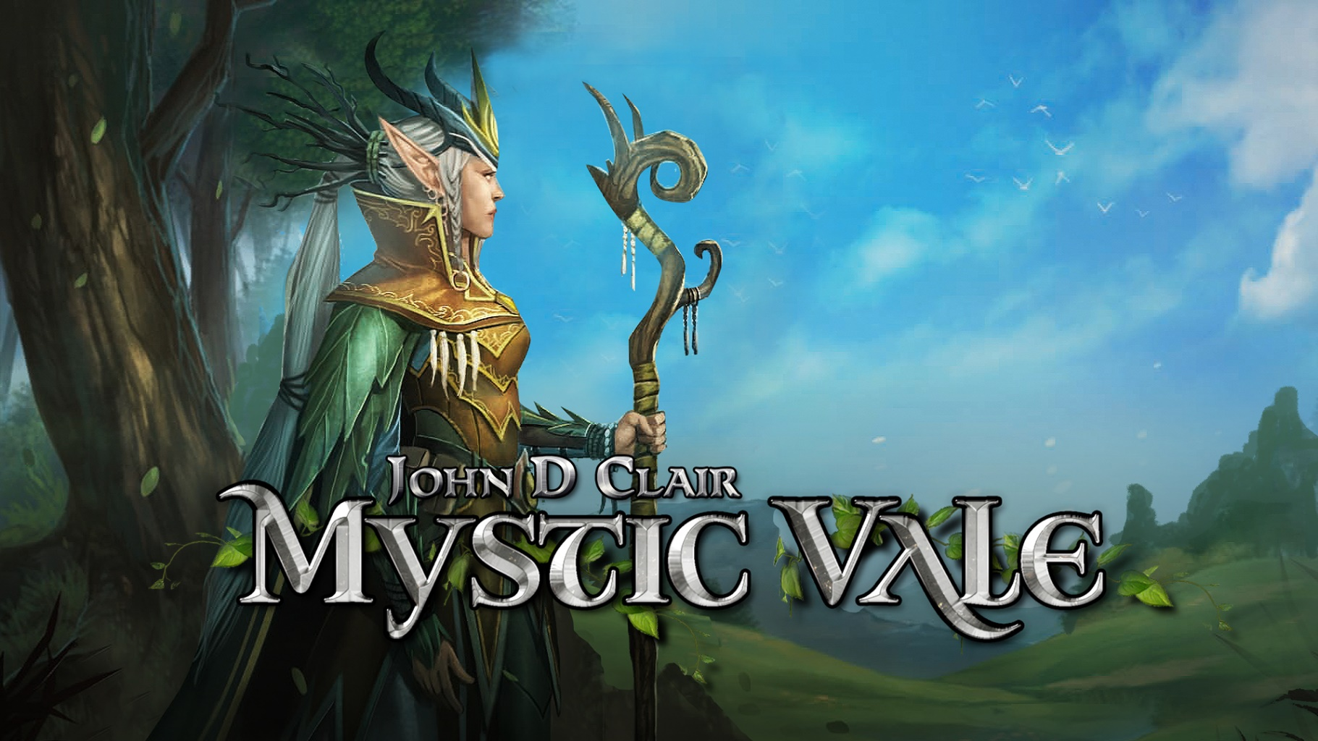

Developer: Nomad Games
Publisher: Nomad Games
Platforms: Steam, Android, iOS, Nintendo Switch
Genre: Board Game, Card Game, Deck Building
#Players: 1-4
Ages: PEGI 7+
Website: www.nomadgames.co.uk/mystic-vale

The Award-Winning, Card-Crafting Mystic Vale
The Valley of Life has been corrupted by an evil curse. When the spirits of nature cry out for aid, clans of mighty druids answer the call. Working together, the clans battle to heal the land, while trying not to succumb to the curse themselves. Mystic Vale is easy to pick up for those new to deck-building games, yet is challenging even for those skilled in the genre. Players can play against AI opponents before taking the battle online, where they can find and create public or private rooms to play against friends or random players!

Mystic Vale (Physical version) is an Origins award winning ‘Card Crafting’ game. Designed by John D. Clair, produced and published by Alderac Entertainment Group (AEG). Mystic Vale debuts the ‘Card Crafting System’ a new type of deck building, where players must build their deck with advancements each game by purchasing cards from the pool with their resources. Players start with a 20-card deck, with each card having three slots for ‘advancements’ which add new effects to your cards. More powerful advancements offer greater resources and rewards, but come with added decay – if you get more than 3 decay in your turn then it’ll end immediately! Do you play it safe or go for the riskier advancements to stop your opponent’s getting them first? It’s all up to you!

Mystic Vale (Digital version) is a complete digital adaptation of the physical edition. In 2019 it was awarded the “Best Game by a Small Studio” by TIGA. Nomad Games has taken the beautiful artwork from the physical game and brought it to life through stunning and bespoke animations. Nomad Games have also worked to bring the Vale of Magic, Vale of the Wild and Mana Storm expansions to the digital adaptation, giving players new strategies, combos and game mechanics to discover and experiment with. Mystic Vale features online and local multiplayer for up to 4 players, and can be played cross-platform against PC and mobile users! Expansions can also be shared with other players – as long as the host has an expansion, all the other players will be granted access to that expansion as well. Players can challenge their friends no matter what platform they’re on!

Mystic Vale - Digital Adaptation History
22/06/2018 - Nomad Games acquires Digital Licence
02/12/2018 - Base Game released on Steam’s Early Access
04/02/2019 - Base Game officially released on Steam
01/03/2019 - Vale of Magic DLC released on Steam
23/05/2019 - Vale of the Wild DLC released on Steam
06/06/2019 - Base Game and Vale of Magic DLC released on iOS and Android
13/06/2019 - Vale of the Wild DLC released on iOS and Android & Cross Platform available
15/08/2019 - Mana Storm DLC released on Steam, iOS and Android
08/11/2019 - TIGA award for ‘Best Game By A Small Studio’
12/03/2019 - Released to Nintendo Switch

Pricing
- Pricing only takes into consideration the game and DLC if bought individually.
- Bundles are available which offer discount when purchasing items together.
- Prices shown are full prices and do not show sale or discount values.
- Prices may vary depending on tax rates in different countries.
Base Game
Platform | GBP | EUR | USD
Steam | £11.39 | €12.49 | $14.99
Nintendo Switch | £16.99 | €18.89 | $21.99
iOS | £4.99 | €5.99 | $5.49
Android | £4.99 | €5.99 | $5.49

Vale of Magic
Platform | GBP | EUR | USD
Steam | £3.99 | €3.99 | $4.99
Nintendo Switch | N/A | N/A | N/A
iOS | N/A | N/A | N/A
Android | N/A | N/A | N/A
*Vale of Magic is included with the base game purchase on Nintendo Switch, iOS and Android.

Vale of the Wild
Platform | GBP | EUR | USD
Steam | £3.99 | €3.99 | $4.99
Nintendo Switch | £5.95 | €6.59 | $7.49
iOS | £1.99 | €2.29 | $1.99
Android | £1.99 | €2.29 | $1.99

Mana Storm
Platform | GBP | EUR | USD
Steam | £3.99 | €3.99 | $4.99
Nintendo Switch | £5.95 | €6.59 | $7.49
iOS | £1.99 | €2.29 | $1.99
Android | £1.99 | €2.29 | $1.99

Social Links
Web: https://www.nomadgames.co.uk/
Twitch: https://www.twitch.tv/nomad_games
YouTube: https://www.youtube.com/c/NomadGamesOfficial
Twitter: https://twitter.com/Nomadgames
Instagram: https://www.instagram.com/nomad_games/
Facebook: https://www.facebook.com/NomadGamesLTD/

More information
If you’d like any more information, please contact press@nomadgames.co.uk

