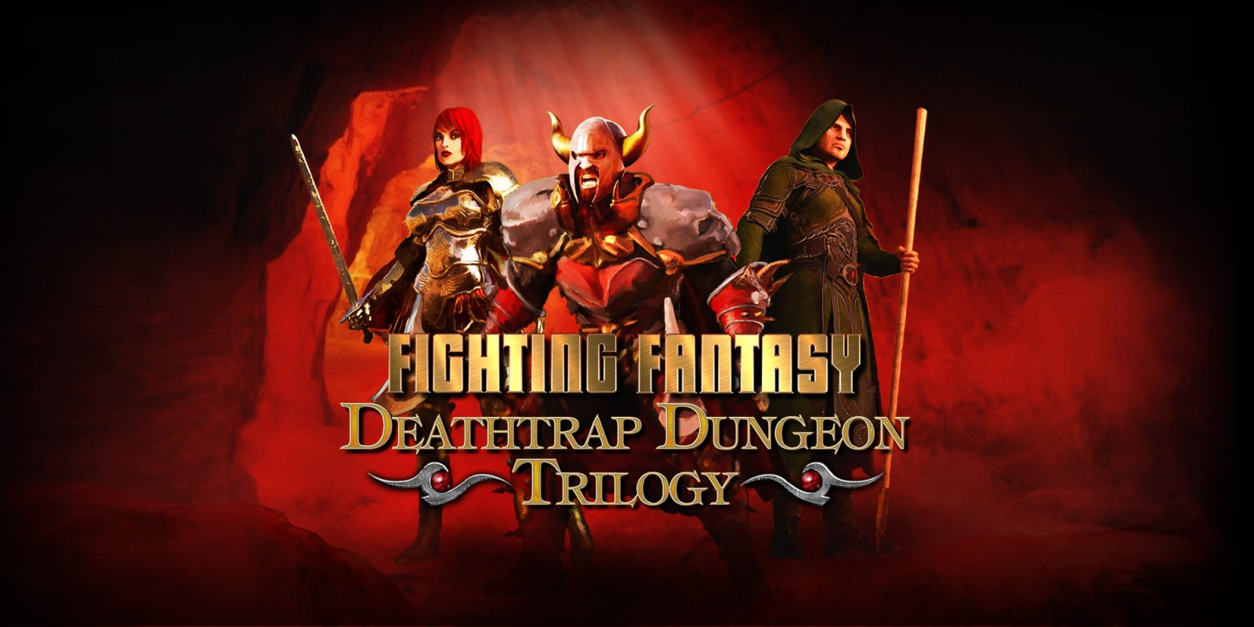
Developer: Nomad Games
Publisher: Nomad Games
Platforms: Nintendo Switch, Windows, iOS, Android
Genre: RPG / Adventure
Release Date: 11 July 2018 (Steam, iOS and Android) November 29th, 2019 (Nintendo Switch)
Players: 1
An Iconic Adventure Awaits!
Adapting three classic Fighting Fantasy gamebooks by author Ian Livingstone, Deathtrap Dungeon Trilogy allows players to rediscover Deathtrap Dungeon, Trial of Champions and Armies of Death digitally on their favourite platforms. From Nomad Games, the studio that adapted three other classic Fighting Fantasy books into the much-loved Fighting Fantasy Legends comes series of classic adventures.
In Deathtrap Dungeon Trilogy, players start as a novice adventurer and rise up through the ranks in three epic tales of deadly traps, fearsome monsters and devious adversaries. Featuring a unique system for upgrading Skill and Luck dice, fans both old and new alike will find lots to love in the Nomad Games adaptation of these iconic books. With changeable difficulty levels for players to experience, even veteran Fighting Fantasy players will need to keep their wits about them.
The game also features a full Creature Codex, where players can track which monsters and beasts they’ve encountered so far in their adventures, such as the Bloodbeast, the Pit Fiend and Agglax the Shadow Demon. Players can also unlock character Titles based on their choices and accomplishments, encouraging exploration and adding replayability.
Deathtrap Dungeon Trilogy is available on Steam, the Nintendo eShop, Google Play and the App Store. Please note, this game was originally released as Fighting Fantasy Legends Portal, but this name was changed in November 2019 on all platforms.

Social Links
Web: https://www.nomadgames.co.uk/
Twitch: https://www.twitch.tv/nomad_games
YouTube: https://www.youtube.com/c/NomadGamesOfficial
Twitter: https://twitter.com/Nomadgames
Instagram: https://www.instagram.com/nomad_games/
Facebook: https://www.facebook.com/NomadGamesLTD/
More information
If you’d like any more information, please contact Thomas Young via press@nomadgames.co.uk

