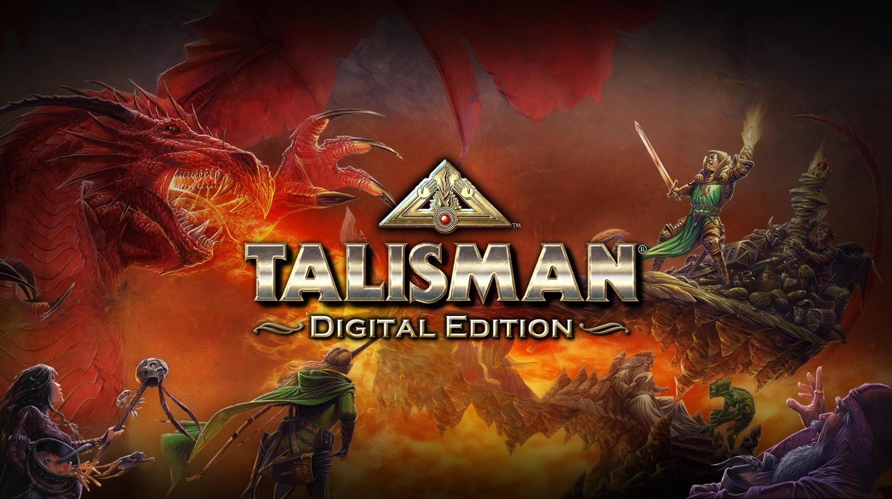
Developer: Nomad Games
Publisher: Nomad Games
Current Platforms: Steam, Android, iOS, PlayStation 4, PlayStation 5, Nintendo Switch, Xbox One, Xbox Series X | S
Genre: Board Game, Fantasy, RPG
#Players: 1-6
Ages: PEGI 7+
Website: www.nomadgames.co.uk/talisman-digital-edition
The Magical Quest Game
The land of Talisman is full of dangerous foes, mighty monsters and unimaginable power… for those brave enough to explore it. Choose from a roster of characters who have unique strengths, weaknesses and special abilities. Select your adventurer carefully as their skills could be the key to you getting your hands on the mighty Crown of Command. A magical artifact that holds the power to destroy all rivals, the Crown of Command has the power to make the bearer the true ruler of the kingdom.
Your adventure to the Crown of Command won’t be an easy one. You’ll need courage, patience and some good dice rolls to survive the dangers you will face. Deadly monsters, tricky traps and magical disasters will try and stop you at every turn!
Talisman is a classic fantasy board game. Originally designed by Robert Harris with Games Workshop producing and publishing the game in 1983.
Talisman: Digital Edition is the much-loved digital adaptation of the classic board game Talisman, and faithfully recreates the classic board game experience, based on the 4th Revised Edition ruleset published by Fantasy Flight Games. The digital edition allows players to battle it out with online and local multiplayer modes for up to 6 players, with cross-platform multiplayer across Nintendo Switch, Steam and mobile. Talisman: Digital Edition is also available on PlayStation 4, Xbox One and Xbox Series X | S, although these three platforms do not support cross-platform multiplayer.
FAQ’s
For our full list of Talisman: Digital Edition FAQ’s please go to https://www.nomadgames.co.uk/talisman-faqs
Social Links
Web: https://www.nomadgames.co.uk/
Twitch: https://www.twitch.tv/nomad_games
YouTube: https://www.youtube.com/c/NomadGamesOfficial
Twitter: https://twitter.com/Nomadgames
Instagram: https://www.instagram.com/nomad_games/
Facebook: https://www.facebook.com/NomadGamesLTD/

More information
If you’d like any more information, please contact press@nomadgames.co.uk

